ASSIGNMENT - 1

# MOTHERBOARD

A motherboard is the central printed circuit board in a computer that serves as the primary hub for connecting and coordinating various hardware components, such as the CPU, memory, storage devices, and peripheral interfaces. It provides the necessary circuitry and connectors for these components to communicate with each other, enabling the overall functionality of the computer system. Often referred to as the mainboard or system board, it plays a crucial role in determining the system's performance and expandability.

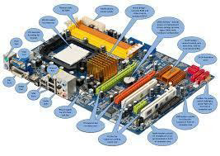

# RAM MODULES

RAM (Random Access Memory) modules are critical components in a computer that serve as temporary storage for data and applications that the system is actively using. This volatile memory allows for rapid read and write access, facilitating quick data retrieval and processing. RAM comes in various types, including DDR (Double Data Rate) generations such as DDR3, DDR4, and DDR5, each offering improvements in speed, bandwidth, and energy efficiency. These modules are typically installed in DIMM (Dual Inline Memory Module) slots on the motherboard. The quantity and speed of RAM directly influence a computer's performance, particularly in scenarios involving multitasking and resource-intensive applications.

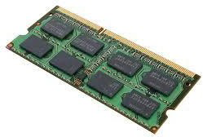

## Daughter cards

Daughter cards, also referred to as daughterboards, are circuit boards that attach to a main motherboard to provide enhanced functionality or features. They expand a system's capabilities by adding components such as graphics processing, network connectivity, or specialized processing units. These daughter cards connect through various interfaces, including PCIe (Peripheral Component Interconnect Express) or proprietary connectors, enabling modular upgrades and customization. This design promotes flexibility and cost-effectiveness, allowing users to replace or upgrade specific components without the need to overhaul the entire system. Common applications of daughter cards include graphics cards, sound cards, and network interface cards. Overall, daughter cards play a vital role in facilitating customization and expansion in electronic devices, enhancing performance and adapting to user needs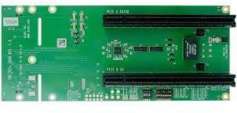

# BUS SLOTES

Bus slots are physical connectors located on a motherboard that enable the installation of expansion cards, such as graphics cards, sound cards, and network interface cards, thereby enhancing a computer system's functionality. These slots facilitate communication between the motherboard and the attached devices by providing a pathway for data transfer. Common types of bus slots include PCIe (Peripheral Component Interconnect Express), PCI (Peripheral Component Interconnect), and AGP (Accelerated Graphics Port), each differing in speed, bandwidth, and specific applications, with PCIe being the most widely used in contemporary systems. By allowing for modular upgrades, bus slots empower users to easily customize and enhance their systems according to their needs. Overall, they are essential for expanding a computer's capabilities and ensuring compatibility with a variety of hardware components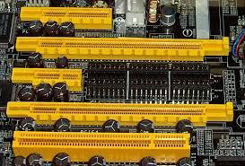

# SMPS

A Switch Mode Power Supply (SMPS) is an electronic power supply that efficiently converts electrical power by utilizing switching regulators to manage the output voltage. Unlike traditional linear power supplies, which dissipate excess voltage as heat, an SMPS operates by rapidly switching the input voltage on and off, significantly reducing energy loss and enhancing overall efficiency. This type of power supply can deliver multiple output voltages and is widely used in devices such as computers, televisions, and various electronic equipment.

SMPS units are typically more compact and lightweight than their linear counterparts, making them well-suited for modern applications where space and weight are considerations. Additionally, they often incorporate safety features such as over-voltage protection and short-circuit protection, ensuring reliable operation and safeguarding connected components. Overall, the SMPS is crucial for providing efficient and dependable power to a wide range of electronic devices.

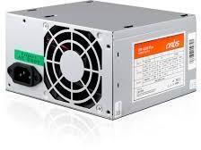

# INTERNAL STORAGE DEVICES

1. **Hard Disk Drives (HDD)**: Traditional magnetic storage devices that use spinning disks to read and write data. They offer large storage capacities (hundreds of GB to several TB) but are slower than SSDs, with average speeds around 80-160 MB/s.

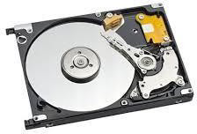

1. **Solid State Drives (SSD)**: Storage devices that use flash memory with no moving parts, providing faster data access and transfer speeds (often exceeding 500 MB/s). They range from 120 GB to several TB in capacity and are ideal for operating systems and applications.

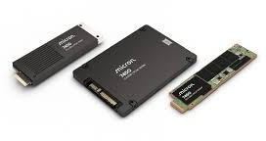

1. **Hybrid Drives (SSHD)**: Combine HDD and SSD technologies, featuring a traditional spinning disk with a small SSD cache. They provide a balance of large storage capacity and improved speed for frequently accessed data.

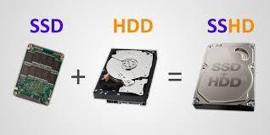

1. **SATA SSDs:** A type of solid-state drive that connects via the SATA interface. While slower than NVMe SSDs, they still offer significant speed improvements over HDDs and are widely used for upgrading older systems.

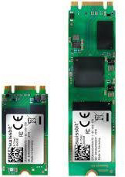

1. **Tape Drives**: Although less common in consumer devices, tape drives are used for archival storage in enterprise environments. They provide high-capacity storage for backup and long-term data retention, though access speeds are slower compared to HDDs and SSDs.

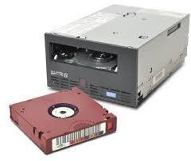

1. **Optical Drives**: Internal CD, DVD, or Blu-ray drives that read and write data on optical discs. While their use has declined with the rise of digital downloads, they are still found in some desktops and laptops for media playback and data storage.

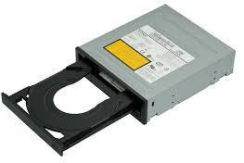

# INTERFACE PORTS

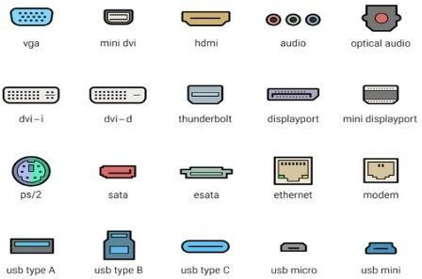

1. **USB (Universal Serial Bus)**: A widely used interface for connecting peripherals such as keyboards, mice, printers, and external storage devices. USB ports come in various versions (USB 2.0, 3.0, 3.1, and USB-C), with newer versions offering faster data transfer rates and improved power delivery.

1. **HDMI (High-Definition Multimedia Interface)**: A digital interface used to transmit

high-definition video and audio from devices like computers, TVs, and gaming consoles to displays. HDMI supports various resolutions and audio formats, making it a standard for home entertainment systems.

1. **Ethernet (RJ-45)**: A port used for wired network connections, allowing devices to connect to local area networks (LANs) and the internet. Ethernet ports support various speeds, including Fast Ethernet (100 Mbps) and Gigabit Ethernet (1 Gbps).
2. **DisplayPort**: A digital display interface primarily used to connect a computer to a monitor. It supports high resolutions and refresh rates, making it suitable for gaming and professional applications. DisplayPort can also carry audio and is capable of

daisy-chaining multiple monitors.

## Desktop Class Computer Specifications

1. **Processor (CPU)**: Desktops usually feature consumer-grade processors, such as Intel Core (i3, i5, i7, i9) or AMD Ryzen series, designed for general computing tasks, gaming, and multimedia.
2. **Memory (RAM)**: Typically equipped with 8GB to 32GB of RAM, desktops can support higher capacities for gaming or content creation. DDR4 is the most common type, with DDR5 becoming more prevalent.
3. **Storage**: Desktops often use a combination of HDDs (for large storage) and SSDs (for speed). Capacities can range from 256GB SSDs to several TB HDDs.
4. **Graphics**: Many desktops include dedicated graphics cards (GPUs) from NVIDIA or AMD for gaming and graphic-intensive applications, while some may use integrated graphics for basic tasks.
5. **Power Supply**: Standard power supplies range from 300W to 850W, depending on the components and performance requirements.

## Server Class Computer Specifications

1. **Processor (CPU)**: Servers typically use enterprise-grade processors, such as Intel Xeon or AMD EPYC, designed for multi-threading and high-performance computing, often with multiple CPU sockets.
2. **Memory (RAM)**: Servers usually have larger memory capacities, often starting at 16GB and going up to several TB, using ECC (Error-Correcting Code) RAM for reliability and stability.
3. **Storage**: Servers often utilize RAID configurations for redundancy and performance, with a mix of SSDs and HDDs. Storage capacities can be extensive, often exceeding several TB, depending on the application.
4. **Network Interfaces**: Servers typically have multiple network interface cards (NICs) for redundancy and load balancing, supporting higher bandwidths (1 Gbps, 10 Gbps, or more).
5. **Power Supply**: Server power supplies are often redundant and hot-swappable, ensuring continuous operation. They are designed for higher efficiency and reliability, typically ranging from 500W to 2000W.